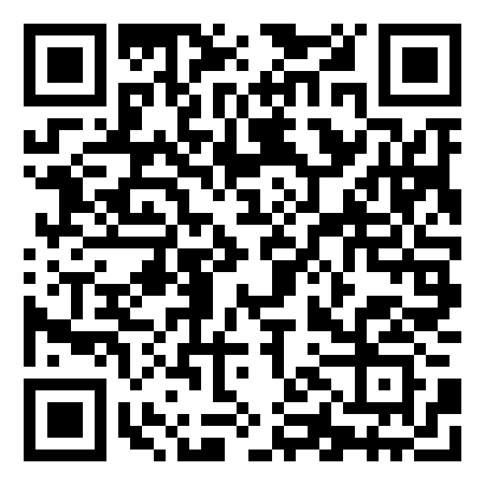zámek 1
https://learningapps.org/display?v=pi3jigyd521

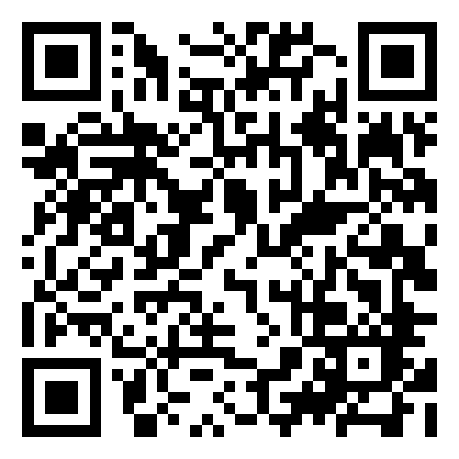č.2
https://learningapps.org/display?v=pnnomeuyc20
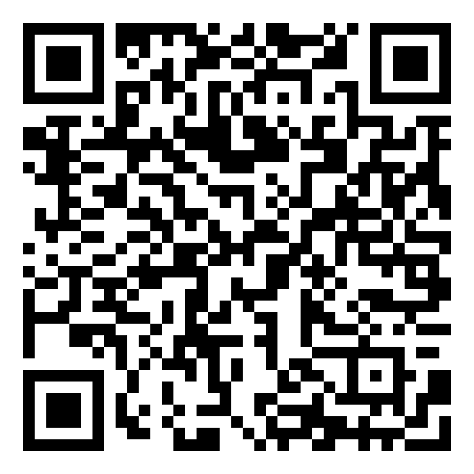č.3
https://learningapps.org/display?v=psr3i30pk20

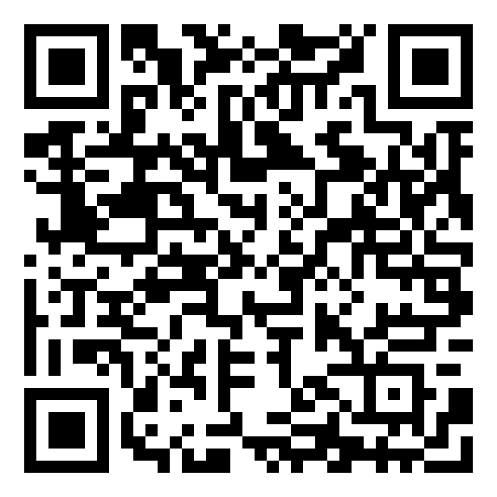č.4
https://learningapps.org/display?v=p0s2kpd8a24
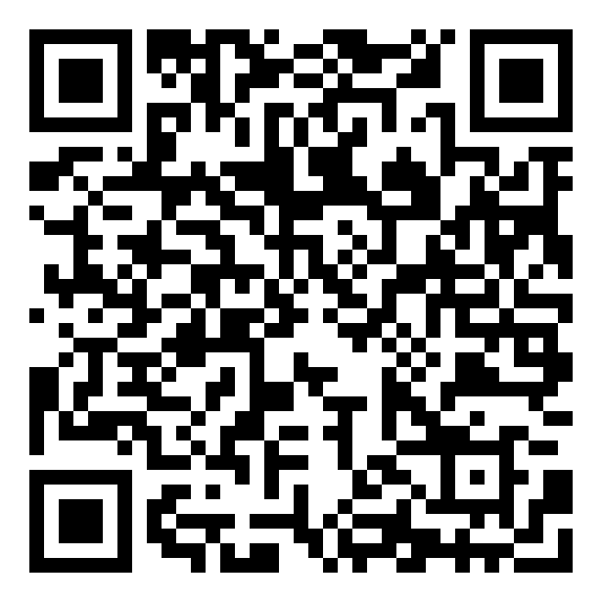č.5
https://learningapps.org/display?v=pm86edpp320

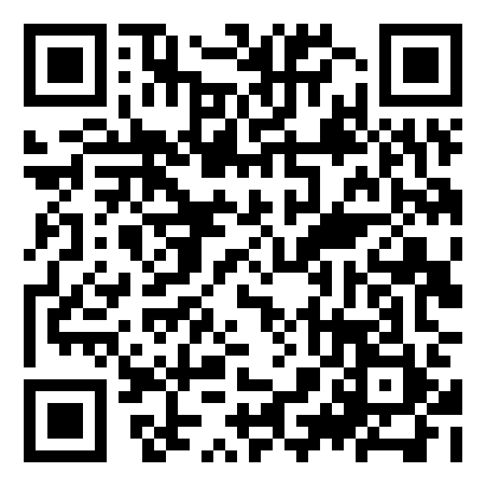č.6
https://learningapps.org/display?v=pm1fwyyyj20

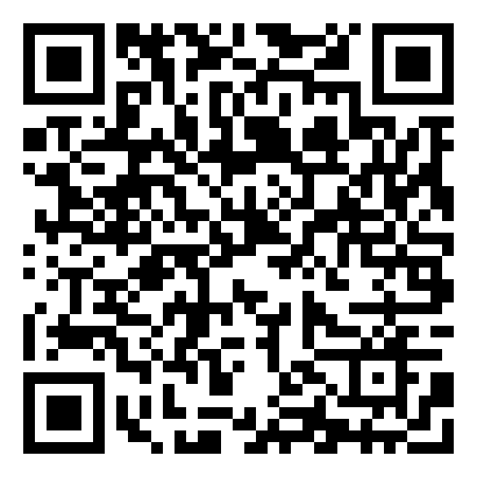č.7
https://learningapps.org/display?v=ptnzrc2vt20

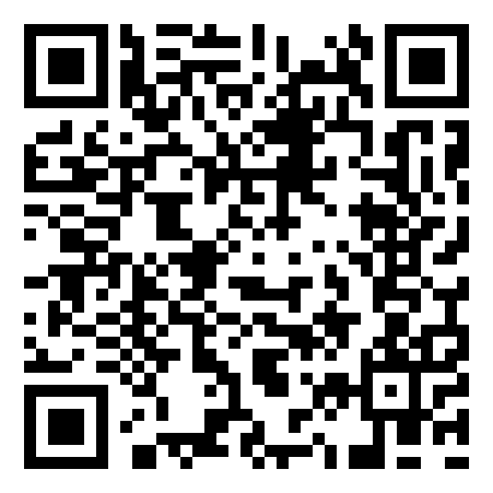č.8
https://learningapps.org/display?v=p32z57qgc20

